**MAE 598 MEDM: Lab # 1**

Group 9: Tolemy Nibi, **Tushar Vishwanath**, Anand Anil Kumar, Sobha Srujana Patri

MAE 598: Topic: Mechatronics Engineering for Design & Manufacturing (MEDM)

Professor Cindy (Xiangjia) Li

Question - LAB 1

Write a brief document to describe what you did for the lab assignment, including:

Pictures of your setup

Circuit schematic diagram

Codes

Comments

1). press the button, blink the yellow LED twice per second for 5 seconds, and then blink the red LED once per second for 5 seconds. Finally, blink the green LED four per second for 5 seconds (+1)  
2). press the button, led all LEDs to blink with a cycle of half a second for 10 seconds (+1)  
3). press the button, leading LEDs to blink simultaneously with different cycles. (+3)  
Yellow led a cycle of half a second for 10 seconds  
Red led a cycle of one second for 10 seconds  
Green led a cycle of two seconds for 10 seconds

**Physical Set Up**

|  |
| --- |
| Circuit Diagram with connections. |
| Figure #: 1 & 2 |

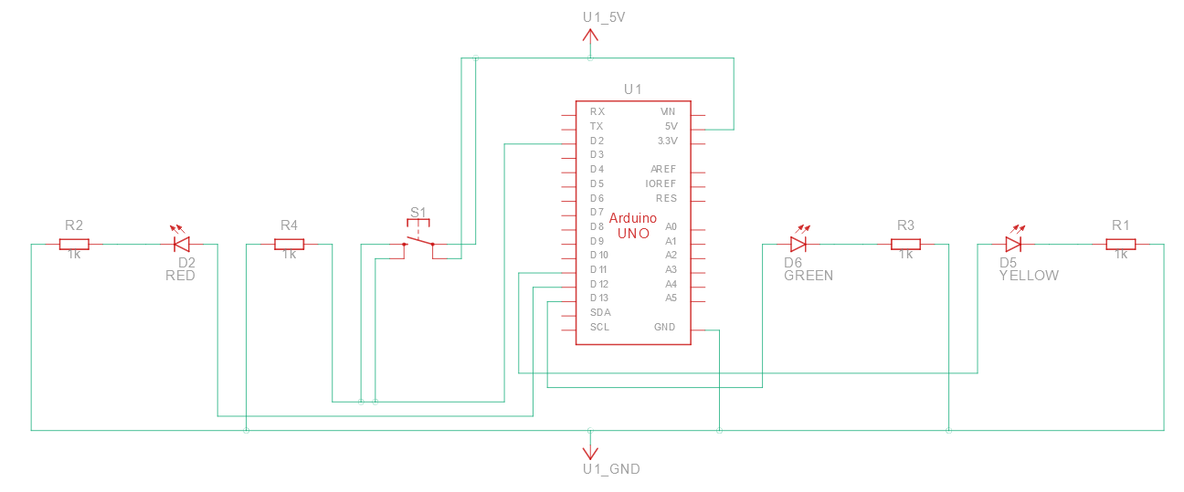

*Figure 1*

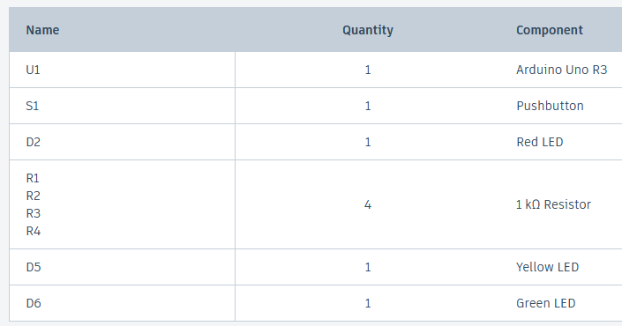

*Figure 2*

*Setup*

**Circuit Schematic Diagram**

|  |
| --- |
| Circuit Schematic Diagram |
| Figure #: 3 |

|  |
| --- |
|  |
| Figure #: 3 |

[Video of Operation](https://drive.google.com/file/d/1FB3v9wiMGuMSFYTLz50-ZQPgomuBeXnv/view?usp=sharing)

TinkerCAD was used to model this circuit.

A five volt power supply and four one kilo Ohms resistors were utilized.

The Green, Red, and Yellow LEDs were connected to digital pins 13, 12, and 11 respectively.

The push button was wired to digital pin 2.

**Code(s)**

|  |
| --- |
| //Write a brief document to describe what you did for the lab assignment, including:  // Pictures of your setup  // Circuit schematic diagram  // Codes  // Comments  // 1. press the button, blink the yellow LED twice per second for 5 seconds, and then blink the red LED once per second for 5 seconds. Finally, blink the green LED four per second for 5 seconds (+1)  // 2. press the button, led all LEDs to blink with a cycle of half a second for 10 seconds (+1)  // 3. press the button, leading LEDs to blink simultaneously with different cycles. (+3)  // Yellow led a cycle of half a second for 10 seconds  // Red led a cycle of one second for 10 seconds  // Green led a cycle of two seconds for 10 seconds  // Arduino code to run the given instructions.    // Define LED pin numbers and button pin number  const int LED_BUILTIN_YELLOW = 11;  const int LED_BUILTIN_RED = 12;  const int LED_BUILTIN_GREEN = 13;  const int buttonPin = 2;  // Counter to keep track of button presses  int buttonPressCounter = 0;  void setup() {  // Set LED pins as output and button pin as input  pinMode(LED_BUILTIN_YELLOW, OUTPUT);  pinMode(LED_BUILTIN_RED, OUTPUT);  pinMode(LED_BUILTIN_GREEN, OUTPUT);  pinMode(buttonPin, INPUT);  // Start serial communication for debugging, can vary - ensure you change in your serial monitor as well  Serial.begin(9600);  }  void loop() {  // Check if the button is pressed, Unfortunately out button is not working in the setup.  if (digitalRead(buttonPin) == HIGH) {  // Increment button press counter  buttonPressCounter++;  // Print the current state to the serial monitor  Serial.print("Current State: ");  Serial.println(buttonPressCounter);  // Based on the button press state, perform different actions  if (buttonPressCounter == 1) {  // **State 1: Blink yellow LED twice per second for 5 seconds, red LED once per second for 5 seconds, and green LED four times per second for 5 seconds**  blinkLED(LED_BUILTIN_YELLOW, 250, 10);  blinkLED(LED_BUILTIN_RED, 500, 5);  blinkLED(LED_BUILTIN_GREEN, 125, 20);  } else if (buttonPressCounter == 2) {  // **State 2: Blink all LEDs together with a cycle of half a second for 10 seconds**  blinkAllLEDs(250, 20);  } else if (buttonPressCounter == 3) {  // **State 3: Concurrently blink yellow, red, and green LEDs with different cycles for 10 seconds**  blinkDifferentCycles();  }  // Reset the counter after reaching state 3  if (buttonPressCounter > 3) {  buttonPressCounter = 0;  }  }  }  // Function to blink a single LED with the specified parameters  void blinkLED(int ledPin, int delayTime, int repetitions) {  Serial.println("LED ON");  for (int i = 0; i < repetitions; ++i) {  digitalWrite(ledPin, HIGH);  delay(delayTime);  digitalWrite(ledPin, LOW);  delay(delayTime);  }  Serial.println("LED OFF");  }  // Function to blink all LEDs together with the given parameters  void blinkAllLEDs(int delayTime, int repetitions) {  for (int i = 0; i < repetitions; ++i) {  digitalWrite(LED_BUILTIN_YELLOW, HIGH);  digitalWrite(LED_BUILTIN_RED, HIGH);  digitalWrite(LED_BUILTIN_GREEN, HIGH);  delay(delayTime);  digitalWrite(LED_BUILTIN_YELLOW, LOW);  digitalWrite(LED_BUILTIN_RED, LOW);  digitalWrite(LED_BUILTIN_GREEN, LOW);  delay(delayTime);  }  }  // Function to concurrently blink yellow, red, and green LEDs with different cycles for 10 seconds  void blinkDifferentCycles() {  // Record the start time for the duration of 10 seconds  unsigned long startTime = millis();  // Elapsed time for the 10 second duration  unsigned long elapsedTime = 0;  // To run the loop for 10 seconds  while (elapsedTime < 10000) {  // Calculate the elapsed time since the loop started  elapsedTime = millis() - startTime;  // Update the states of the LEDs based on their specific cycles  digitalWrite(LED_BUILTIN_YELLOW, (elapsedTime % 500 < 250) ? HIGH : LOW); // Yellow LED: cycle of half a second  digitalWrite(LED_BUILTIN_RED, (elapsedTime % 1000 < 500) ? HIGH : LOW); // Red LED: cycle of one second  digitalWrite(LED_BUILTIN_GREEN, (elapsedTime % 2000 < 1000) ? HIGH : LOW); // Green LED: cycle of two seconds  }  // Turn off all LEDs after the 10-second duration  digitalWrite(LED_BUILTIN_YELLOW, LOW);  digitalWrite(LED_BUILTIN_RED, LOW);  digitalWrite(LED_BUILTIN_GREEN, LOW);  }  // Unfortunately as our push button is not working our LEDs will not turn off in the real setup |
| Note - In case of spacing issues the txt file has been attached here - [link](https://docs.google.com/document/d/1WhLeZAi0J_L8eU4KdneY5ldwUSoKtvCTR-QiY1DgNEk/edit?usp=sharing) |

**Closing Comments:   
We kept the connections to a minimum and ensured the code did most of the work. Please watch the linked video for the final operations process.**